Log in on Yonsei portal
https://portal.yonsei.ac.kr/

ID : Student ID number
Password : Your date of birth (YYMMDD)

Select ‘Academic Information System’ under YONSEI SERVICE

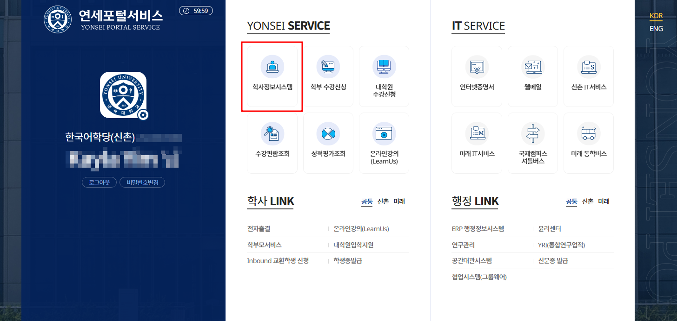

To apply for Yonsei dorm, select ‘Dormitory Application’

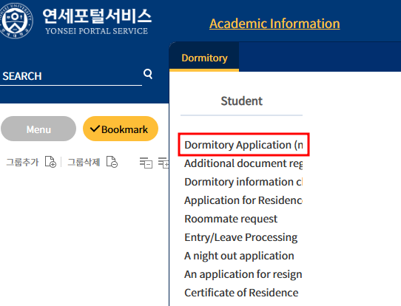

Fill out the request information for the application. Columns with red flags are mandatory.

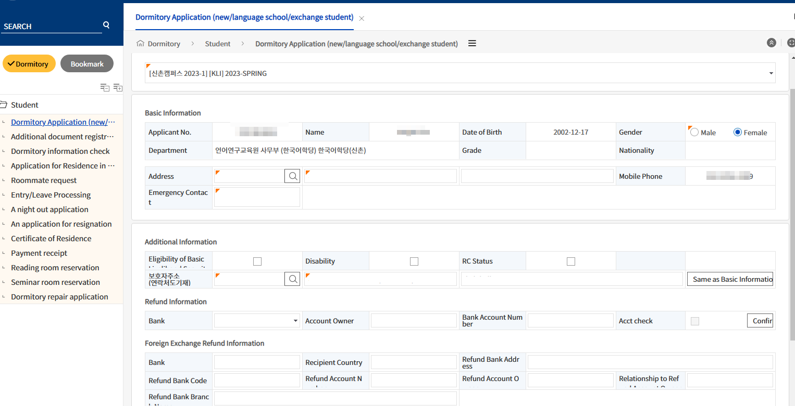

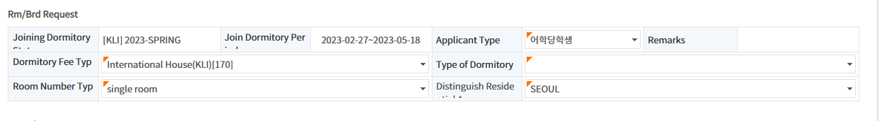
Under Additional Information session, ‘Guardian Address’ refers to the current address of your legal guardian. In order to input the address, select the search  button.

If your legal guardian lives in South Korea, type the full Korean address, and select the corresponding option. Fill out the remaining detailed address manually.

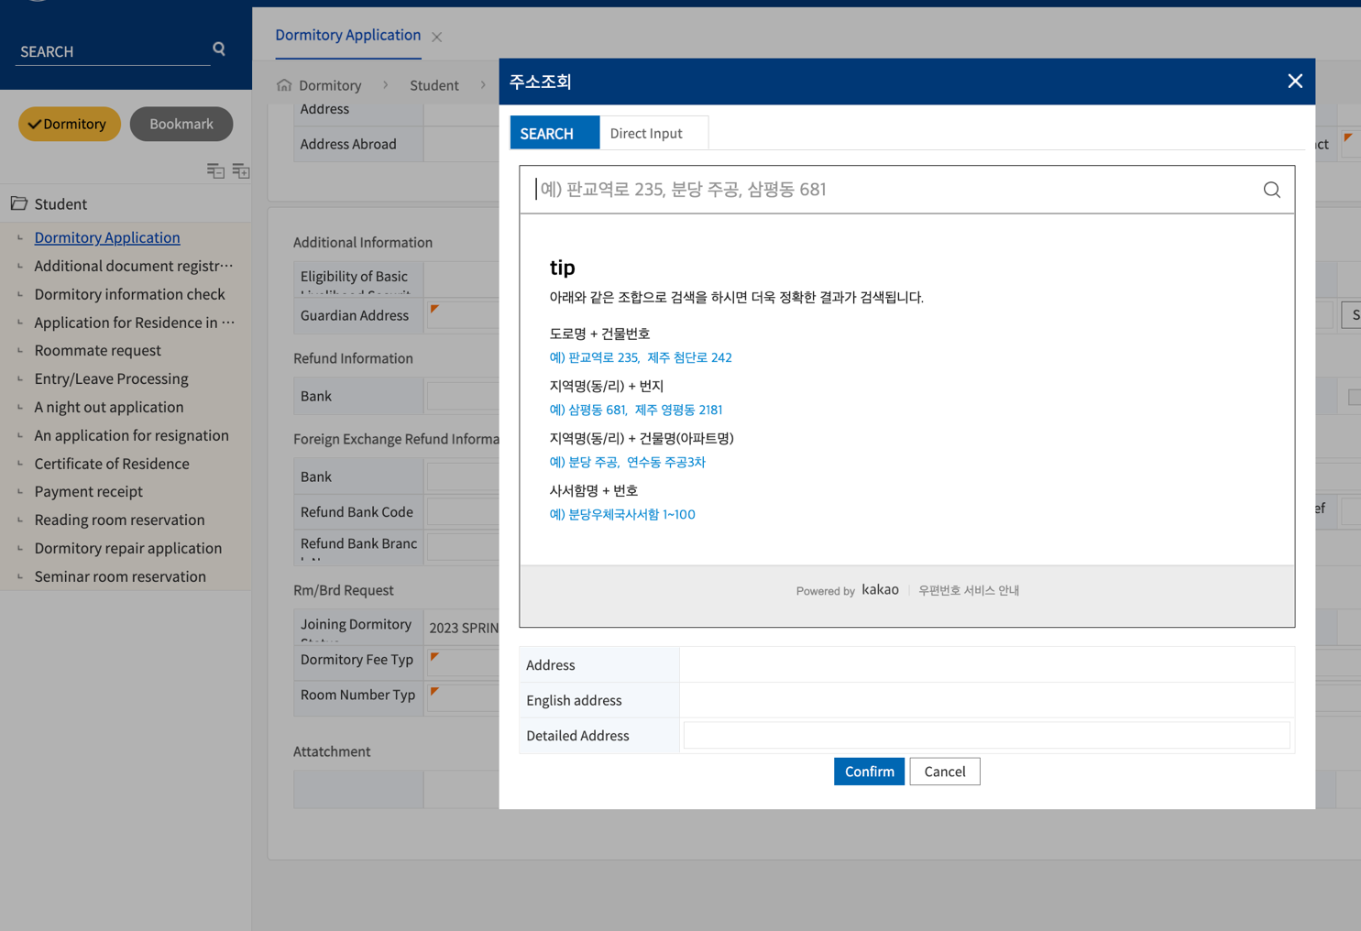

If the address does not appear under ‘SEARCH’ or your legal guardian lives abroad, select ‘Direct Input’. Here, you can manually type the address and postal code. Click Confirm once you are done filling out the address.

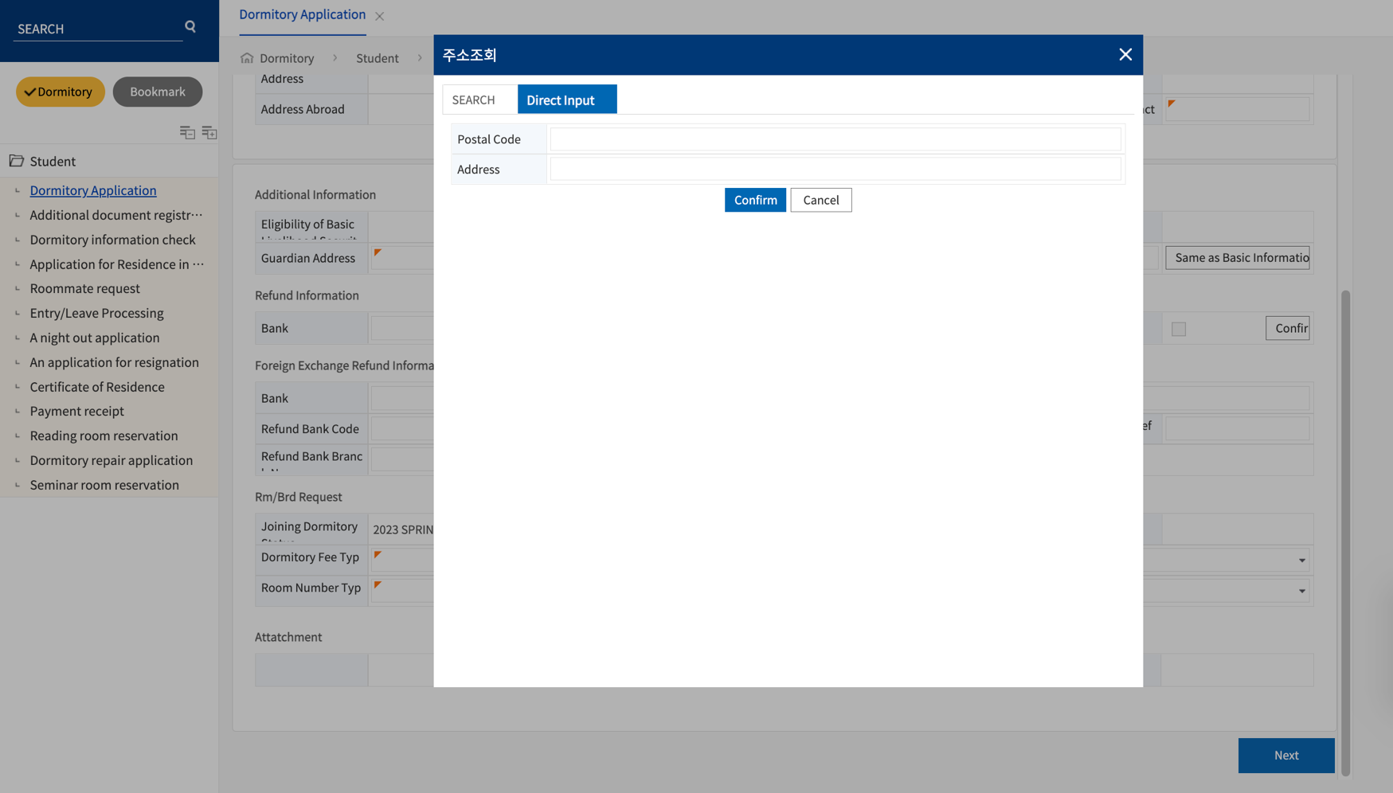

In case you need a refund of your dorm fees in the future, it is advised to input your bank information. (Not madatory)
- If you have a Korean bank account fill out your information in ‘Refund Information’. For ‘Bank’, select the button and choose the Korean bank branch that you are using. After that, input your legal name in ‘Account Owner,’ account number in ‘Bank Account Number,’ and select ‘Acct check’. Click Confirm once you are done filling it out.
- If you do not have a Korean account, fill out your abroad account information under ‘Foreign Exchange Refund Information.

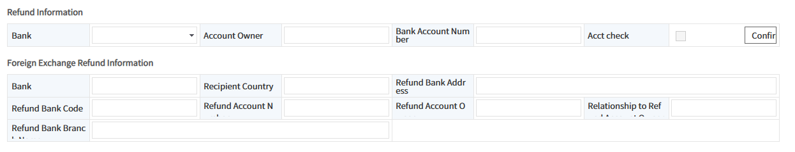

In order to select the ‘Dormitory Fee Type’, select the button and choose from one of the three options.

The ‘Room Number Type’ is the room number you selected. The SK Global House has both single and double room, and the International House only has double room.

For ‘Distinguish Residence’, select the option for ‘SEOUL’.

For ‘Joining Dormitory Questions’ select the checkbox according to the questions and reply.

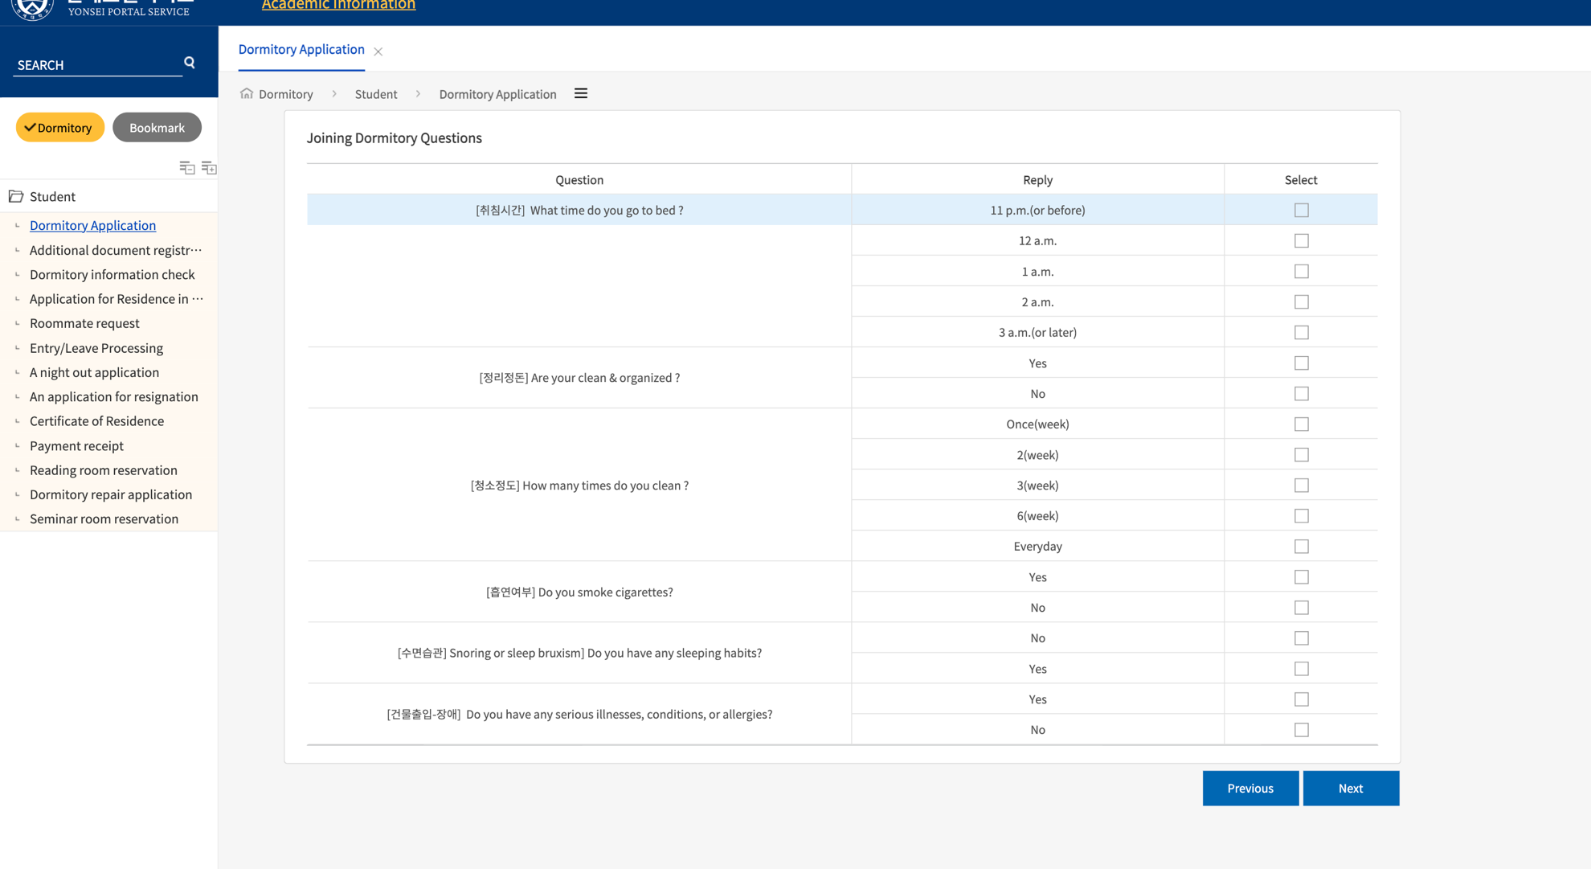

Double check the information in the final stage ‘Check Application Details’. Select ‘Complete’ for submission of application.

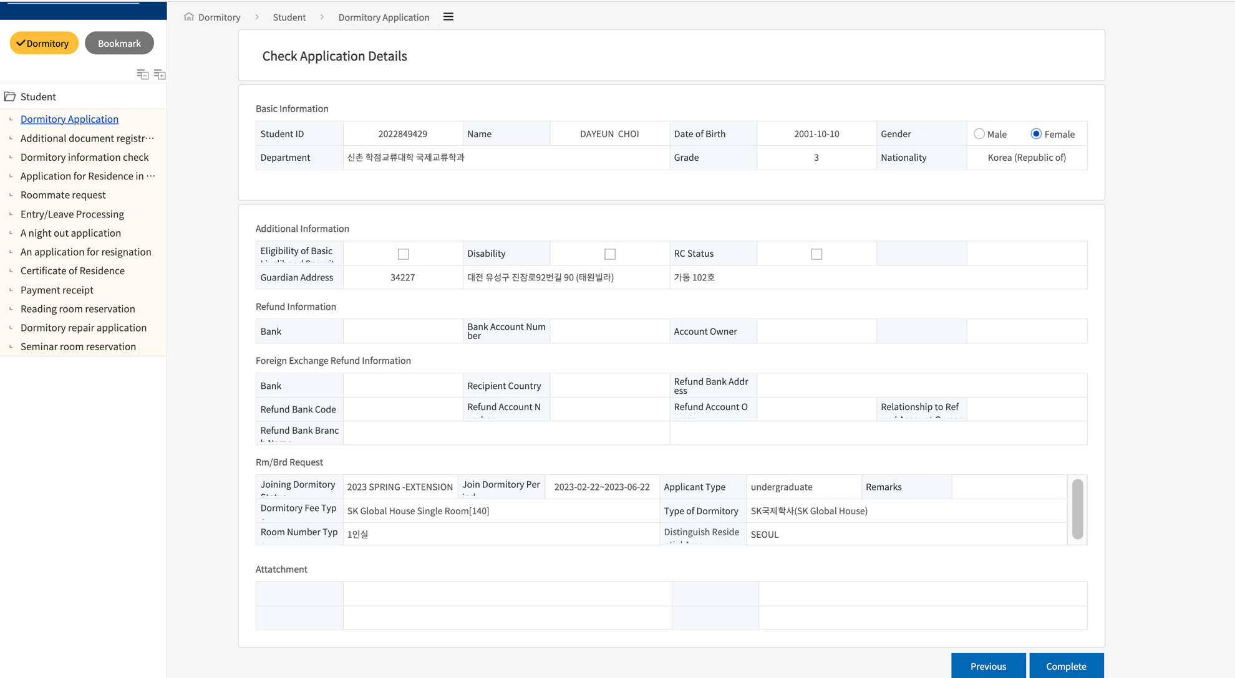

If you see this page at the end, your application has been successfully submitted. If you need to cancel your application, select ‘Cancel Application’.



